README:
- Submit your homework to Webcourse.
- You are encouraged to consult AI tools for assistance. However, please ensure that you fully understand the material and concepts.

Lab1: DV routing algorithm (50 pts)
The goal of this lab is to implement and analyze the Distance Vector (DV) routing algorithm in simulated network environments. The focus is on understanding how routing tables evolve through iterative communication (i.e., convergence behavior).
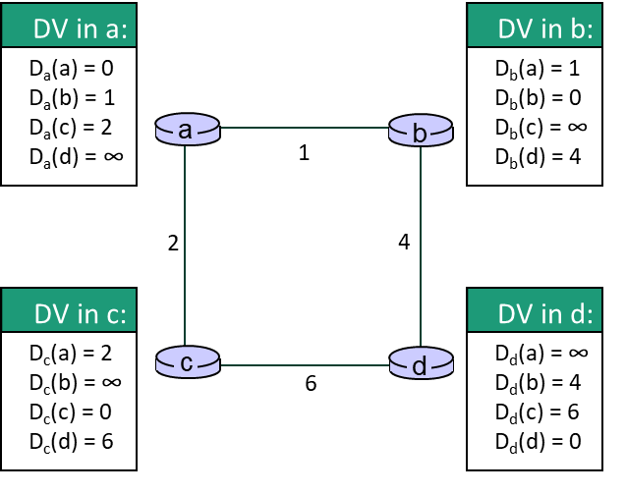
Task1-1: DV routing for a 2x2 node network.
As shown in Figure 1, there are 4 nodes, i.e., a, b, c, and d. In the initial state, DV tables only contain the distance values of neighbors, and for non-neighbors, the distance is infinite. Write a program, in any available language, such as C++, java, and python, to implement the DV (distance-vector) routing. Specifically, your code should be able to print all DV tables for all iterative communication steps.
Figure 1
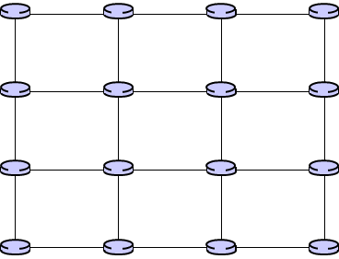
Task1-2: DV routing for a 4x4 node network.
In this task, the number of nodes is increased to 16 (Figure 2). As in task1, the initial DV tables only contain the distance values of neighbors. The distance values, which should fall between 0 and 10, are randomly generated in your code. Write a program that can show all DV tables for all iterative communication steps.
Figure 2
Question:
- For an NxN network, how many iterations does it require to complete the DV routing?
- In figure 2, what could be the potential impact if one specific link becomes disconnected (i.e., its distance becomes infinite)?
Deliverable:
- Written answers to the two questions above.
- Your source code, including comments that explain the critical parts of the implementation (An example is shown on page 3).
- A screenshot of your results showing all DV tables for all iterative communication steps in the above two tasks (An example is shown on page 3).

Lab2: Protection strategies (50 pts)
The goal of this lab is to gain insights into data protection strategies by exploring various error detection and error correction schemes. It is important to understand the algorithms and the pros and cons of these schemes.

Task2-1: Basic error detection and error correction schemes.
Write a program, in any available language, such as C++, java, and python, to implement CRC and SEC-DED (single error correction double error detection). Specifically, CRC is based on 0x107 (x⁸ + x² + x + 1). The input is a fixed 64-bit value (0xFA78 16EB 87CC 0911). The program should compute and output both the 8-bit CRC and the SEC-DED encoded result.

Task2-2: Evaluating the error detection capability.
Randomly inject the following five types of errors into the input value:
(1) A single-bit error; (2) Two random-bit errors; (3) Three random-bit errors;
(4) An 8-bit burst error; (5) A 16-bit burst error.
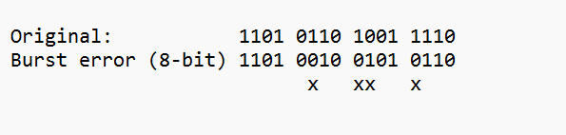
For each error type, run 1,000,000 iterations and record how often each scheme detects the error. Summarize and compare the error detection rates of CRC and SEC-DED for each case. NOTE that for an n-bit burst error, the first and last bits are in error, and any number of intermediate bits may also be incorrect (with a 50% probability in this homework). An example is shown below.

Question:
- What is the concept of hamming distance? Why cannot SEC-DED correct two errors?
- Typically, SEC-DED is implemented using combinational circuits, while CRC is implemented using sequential circuits. Is it possible to implement CRC using combinational circuits?
Deliverable:
- Written answers to the two questions above.
- Your source code, including comments that explain the critical parts of the implementation.
- A screenshot of your results showing both the 8-bit CRC and SEC-DED outputs in task2-1.
- Summarizing the percentage of errors in task2-2 using the table below.

Error type | CRC Detection Rate (%) | SEC-DED Detection Rate (%)
A single-bit error
Two random-bit errors
Three random-bit errors
An 8-bit burst error
A 16-bit burst error

Example: code with comments that explain the critical parts of the implementation
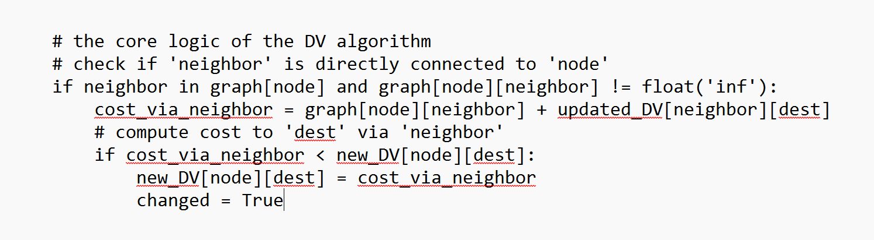

Example: a screenshot of task 1-1 results. NOTE that there is only one iteration in task 1-1.
